**CS 401** **Final Project**

**[Manual document](https://docs.google.com/document/u/0/d/157Ei5L4BHRmZc-hTyXLenBhOY4WMWYMcFXXI4CRJvQM/export?format=docx)**

Yuhan Li

A20431466

Han Wang

A20417580

11/17/2018

# Main Menu

When enter the main menu, you will see the message below, Then you need to input a number from 1 to 7 to select a submenu.

If you are the first time enter the main menu, you must create course roster and input grade at first.

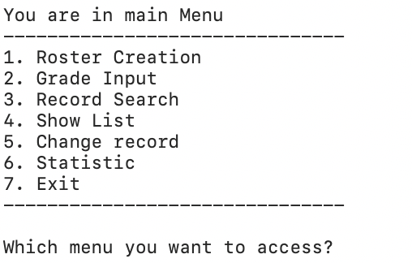

# Menu1

When you enter menu 1, the system will generate a course roster, and define some information of this course. Then, you will return to main menu.

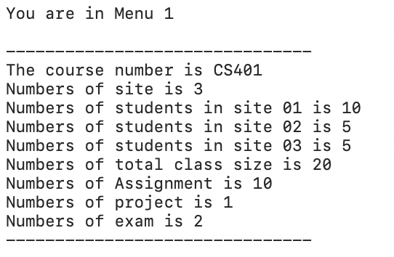

# Menu2

When you enter menu 2, the system will input file which called grade.txt from the location where the system in.

After input successful, the system will show information below.

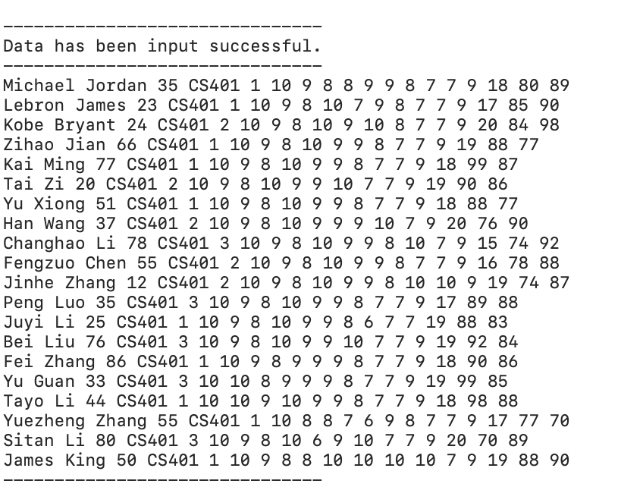

# Menu3

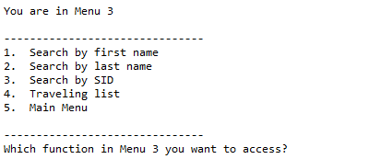

When you choose the menu3 you will see the following words. In the menu3, we can realize four functions: search by first name, last name and SID, and show the traveling list.

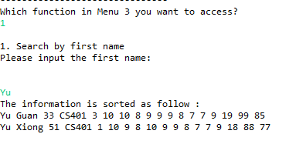

When we choose 1, we can search the information of students by first name

For example: we search “Yu”, it will show all the students whose first name is “Yu”

If there are more than one same first name, the result shows all of them, but they are sorted by the last name. If there are multiple same first and last names, then the result is sorted by SID.

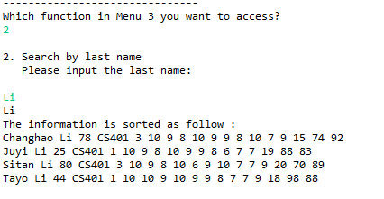

When we choose 2, we can search the information of students by last name.

For example: we search “Li”, it will show all the students whose last name is “Li”

If there are more than one same last name, the result shows all of them, but they are sorted by the first name. If there are multiple same first and last names, then the result is sorted by SID.

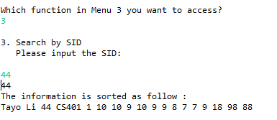

When we choose 3, we can search the information of students by SID.

For example: we search “44”, it will show all the students whose last name is “44”. Becasue, the SID is unipe, so there are no more than one same SID.

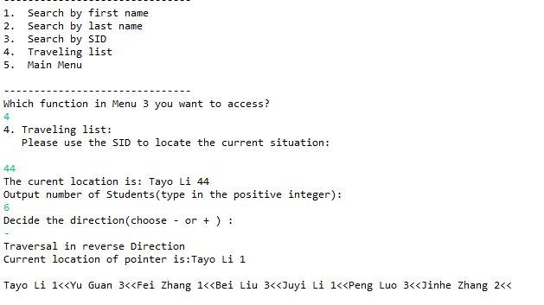

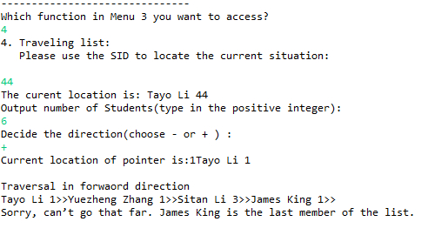

When we choose 4, we can show traveling list. We creates a linked list and it needs two parameters and they are the position number with the forward or backward direction (+ or -).

We need to input SID first to find current location . Then input the number of students you want to output. At last, choose the direction, reverse ( - ) or forward ( + ).

If the reference reaches the end node or the head node before moving forwards or backwards to the designated position, output shows an error message

“Sorry, can’t go that far. XXX XXX is the last member of the list. “ or

“Sorry, it’s beyond the scope. XXX XXX is the first element of the list. ”

# Menu4

When you enter menu4, you will see message below, you need to change a function to use.

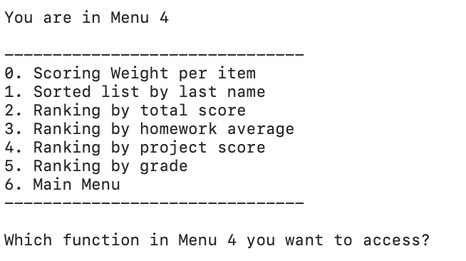

For function 0, the system will set weight for different score. After setting, the program will output Weight has been set successful.

For function1, the system will sort the record by sorted list (in ascending order) by Class, Site, and last name. The result will look like below.

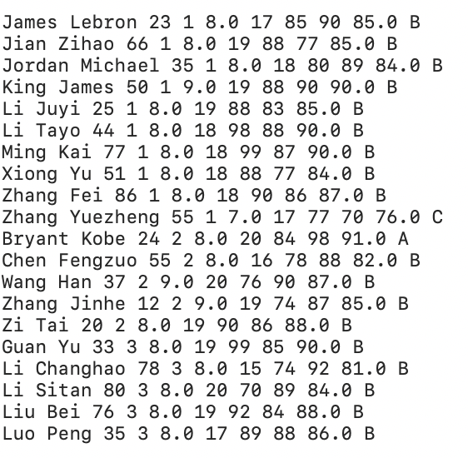

For function2, the system will sort the record by total score.

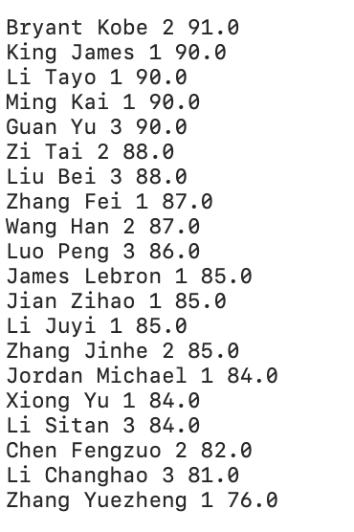

For function3, the system will sort the record by homework average.

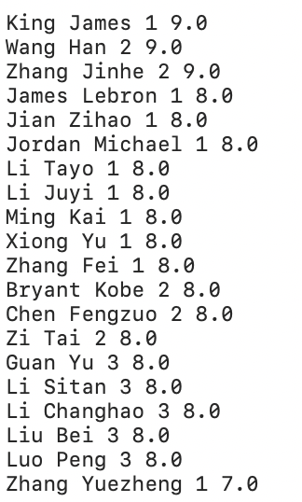

For function4, the system will sort the record by project score.



For function5, the system will sort the record by grade.



For function6, you will return to main menu.

# menu 5

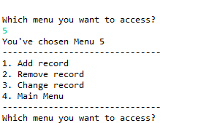

Menu5 have four choices.

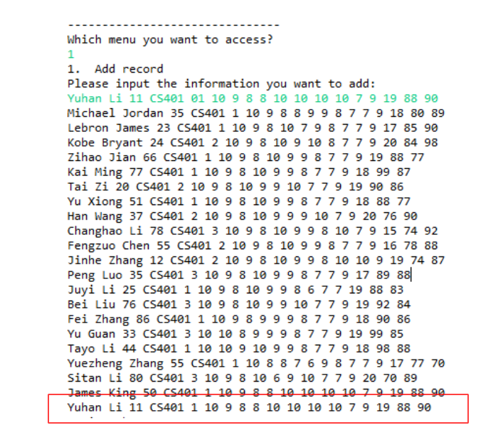

1.add record

Menu 5.1 adds a new student record to the list by manual user interaction.

After inserting a student record, verifies the new record into the screen

We input the new message and it will be added to database.

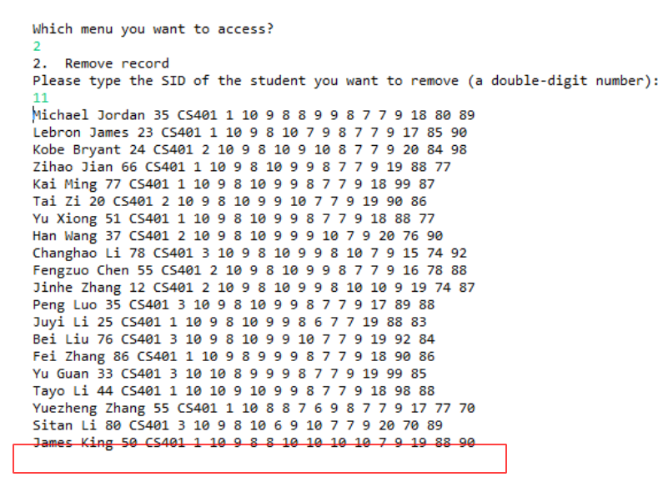

Menu 5.2 deletes a person from the list. Finding a person by SID, and remove the student.

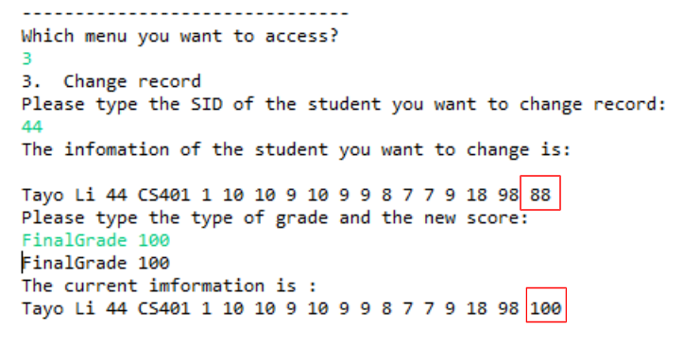

Menu 5.3 changes score(s) of a record(s). We finding a person by SID, and the input the type of grade and the new score( Grade name + score ). The information will be changed.

# Menu6

When you enter menu 6, you will see the message below, you need to select a function in menu 5.

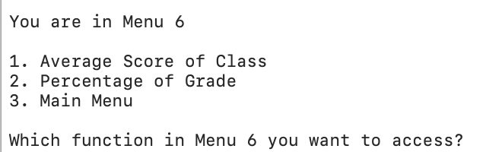

For function 1, shows averages of all categories:

# Menu7

Quit the system.

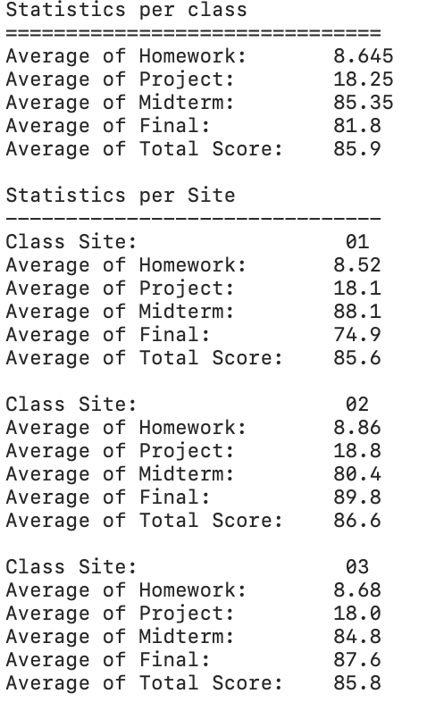

For function 2, shows the percentage of each grade category (A, B, C, E)

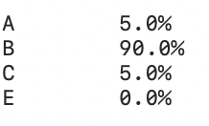

For function 3, you will retuen to main menu.

**Menu7,**

When you enter menu 7, you will exit the system.